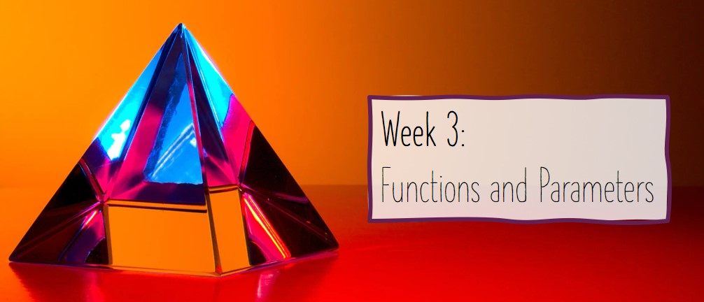

3.6-3.8: Hybrid Session 1

This document has been updated to reflect the materials which were covered and shared within the session.  Anything new is highlighted in purple.

In this topic, we will be focussing on the following learning outcome for this week:

* Define the purpose of functions within programming
* Apply functions to problems with varying quantities of parameters

You will have the following learning opportunities:

* To understand key terms in relation to functions within programming
* To implement and use functions with varying numbers of parameters
* To experiment with the return keyword in functions

Prefer to complete this activity offline? - download the following documents:

* Full PowerPoint Slides: [Week 3 Hybrid Session 1 Full Slides.pptx](https://winchester.instructure.com/files/1671750/download?wrap=1)
* Walkthrough Documents:
  + [3.7 Defining Functions in Python (Hello World) Walkthrough.docx](https://winchester.instructure.com/files/1671739/download?wrap=1)
  + [3.7 Defining Functions in Python (Multiplying 4 Numbers) Walkthrough.docx](https://winchester.instructure.com/files/1671740/download?wrap=1)
  + [3.7 Functions in Python Worksheet (Question 2) Walkthrough.docx](https://winchester.instructure.com/files/1671742/download?wrap=1)
  + [3.8 Return Statement Walkthrough.docx](https://winchester.instructure.com/files/1671743/download?wrap=1)
* In Class Worksheet: [3.7 Defining Functions in Python Worksheet.docx](https://winchester.instructure.com/files/1671741/download?wrap=1)

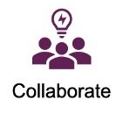

During this hybrid session, you will be engaging in acquisition, collaboration, discussion, practice learning activities.

# 3.6: Welcome to the Session

In this part of the session, we will introduce the topics we are planning on covering during this hybrid session. For this session we will be focussing on the following topics:

* Recapping Key Definitions of Functions;
* Defining functions in Python; and
* The Return Statement

In this part of the week, we also recapped the key terminology covered within the pre-session materials.  We completed a Padlet which contained each group's version of the definition – you should find the link to this within your seminar group channel.

# 3.7: Defining Functions in Python

Throughout this week we will be discussing how we define functions within Python. We are going to start with the elementary functions in Python – those without parameters or return statements. We will be building these during the rest of the content this week. Once you have seen a demo of creating a function, you will be given another example to practice, which makes use of designing functions using pseudocode, which was covered during the pre-session materials.

This section saw us do a couple of demonstrations.  We also shared a worksheet which had examples for you to practice.  We have also included a walkthough which talks you through how to complete the second question – if you have not attempted this question, please have a try before looking at the walkthrough.

# 3.8: The Return Statement

In this section, we will be introducing you to the concept of the return statement, together with its associated uses. We will complete a demonstration which shows the implementation of this key element of functions. We will also show how the information returned can be used.

In this section, we built on our discussion and understanding of functions to include the return statement, rather than simply printing the output.